Alfred Acosta

Database Management

2/27/17

Lab 6

Left outer join vs Right outer join

An inner join selects all rows form both tables if there is a match between the columns in both tables. While this is useful, it must be specific, whereas outer joins simply return all the rows from both tables. This can be useful when it comes to comparing them, and what we use to compare them are Left outer joins and Right outer joins. The tables are separating into left and right while using a outer join. So, a Left outer join returns all the rows from the left table with the matching rows on the right. If there is no match on the right side, the result for that row is NULL. A right outer join is the opposite, where it returns all the rows from the right table with the matching rows on the left, and where there is no match, the result is null. These can be useful when trying to compare data from both tables, while also finding what data from one table doesn’t exist on the other table. As you can see in the example below, with the use of a left outer join, the customer Alan exists in the left table but not in the right table, so all the rows in the right table are NULL. On the other hand, with the Right outer join, Alan doesn’t exist on the right table, so the row for Alan does not appear in the results.

Example of left outer join:

Select \*

from customers left outer join orders on customers.cid = orders.cid;

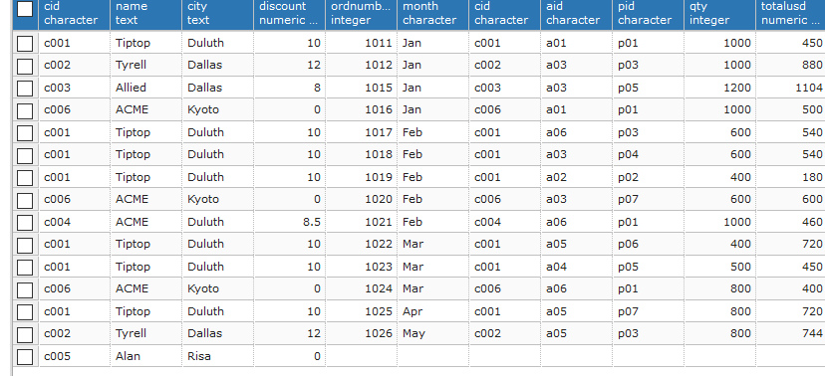

Example of right outer join:

Select \*

from customers right outer join orders on customers.cid = orders.cid;

